# 20-03-25

## Create a News Component Using Sling Model

Develop a new component with the following fields:  
- `News Title` (displayed as `<h2>`)   
- `News Detail` (displayed as `<p>`)   
- `Published Date`  
- `Source`  
Use a Sling Model to fetch and display the values.

Modify `newsComponent.html`:  
```html  
<div class='news'>  
 <h2>${newsModel.newsTitle}</h2>  
 <p>${newsModel.newsDetail}</p>  
 <p class='date'>Published on: ${newsModel.publishedDate}</p>  
 <p>Source: ${newsModel.source}</p>  
</div>  
```

Path: http://localhost:4502/mnt/override/apps/myTraining/components/news/_cq_dialog.html/content/myTraining/us/en/jcr:content/root/container/container/news_407793687?page=true&resourceType=myTraining%2Fcomponents%2Fnews

## Create a Multi-Field Component Using Sling Model

Develop a multi-field component that supports multiple news items. Fields include:  
- `Title of News`  
- `Source of News`  
Steps:  
1. Use Sling Model to create multiple news entries.  
Modify `_cq_dialog.xml`:  
```xml  
<items jcr:primaryType='nt:unstructured'>  
 <news jcr:primaryType='nt:unstructured' sling:resourceType='granite/ui/components/coral/foundation/form/multifield'>  
 <field jcr:primaryType='nt:unstructured' sling:resourceType='granite/ui/components/coral/foundation/form/textfield' fieldLabel='News Title' name='./newsTitle'/>  
 </news>  
</items>

## Create Clientlibs for the News Component

Develop client-side libraries (clientlibs) for styling and scripting the news component.

Create `/apps/myProject/clientlibs/news` and add `css.txt` and `js.txt`.

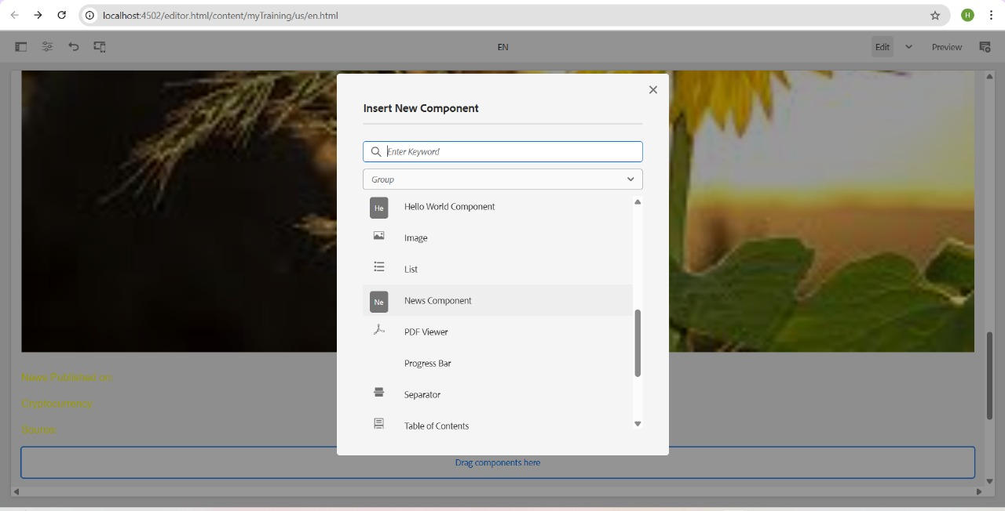

## Apply Styles to the News Component

- `h2` (News Title) → Green  
- `p` (News Detail) → Yellow  
- `Published Date` → Black

## Add a Custom Style Name to the News Component

Configure the component to allow adding a custom style name (`cop-news-component`).

## Create a Base Page Component with Metadata

Modify `basepage.html` to include:

<meta property='og:title' content='${properties.ogTitle}'/>

<meta property='og:description' content='${properties.ogDescription}'/>

<meta property='og:image' content='${properties.ogImage}'/>

## Create Custom Page Properties (Global Properties)

Develop custom page properties under 'Global Properties' with the following fields:  
- `og:title`  
- `og:description`  
- `og:image` (path)

## What is extraClientLibs & How to Use It?

`extraClientLibs` is a feature in AEM that allows additional client-side libraries to be loaded dynamically. Apply `extraClientLibs` in the multi-field news component to extend its styling and functionality.